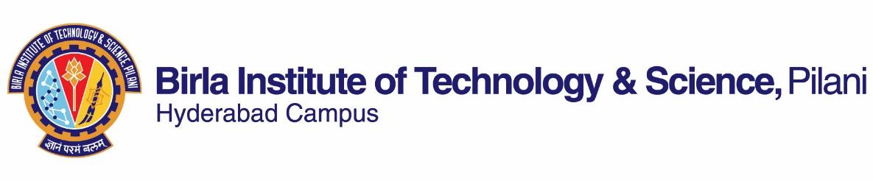

**ACADEMIC – GRADUATE STUDIES AND RESEARCH DIVISION**

**BIRLA INSTITUTE OF TECHNOLOGY AND SCIENCE, PILANI-HYDERABAD CAMPUS**

**FIRST SEMESTER 2021-2022**

**Course Handout Part II**

**Date:** **12/08/2021**

In addition to Part-I (General Handout for all courses appended to the Time Table) this portion gives further specific details regarding the course.

**Course No. :** CE G552

**Course Name :** Advanced Structural Mechanics and Stability

**Instructor-in-Charge :** Dr.Shivang Shekhar (shivangshekhar@hyderabad.bits-pilani.ac.in)

# Course Description

Analysis of stress and strain in three dimensional domain, deviatoric stress and strain; stress and strain invariants, compatibility conditions, equilibrium equations; stress-strain relations for anisotropic, orthotropic and isotropic elastic materials; yield criterion; plastic potential and flow rules. Problems on plane stress and plane strain conditions, Airy stress function; Axisymmetric problems; torsion of prismatic bars, circular and non-circular sections; thin-walled sections, membrane and sand-heap analogies, concept of stability of structures and examples of instability. Stability of structures with one and two degrees of freedom, buckling of columns; beam-columns and simple frames, lateral torsional buckling of beams; and introduction to post-buckling analysis of plates.

# Scope and Objective

This course is basically a mixed course of advanced structural mechanics and stability of structures. This course deals with the study of stresses and strains in three dimensions along with a slight introduction to the tensor notation. The compatibility conditions and equilibrium equations are discussed. Plane stress and plane strain conditions are also discussed in this course. The problems involving axisymmetric conditions are also covered. Theory of plasticity is covered through the concepts of yield criteria, plastic potential and flow rules. Nowadays, composite materials are being used in many situations due to their various advantages. The stress-strain relationships of orthotropic and anisotropic materials are discussed. The behavior of circular and non-circular sections under torsional load is studied. The concept of stability of structures is discussed. The buckling of column, beam-column and simple frames are covered. The torsional buckling problem of beams and post-buckling characteristic of plates are discussed in this course.

This course is also covering many advanced topics in structural mechanics and stability of structures. At the end of the semester, students will be in a position to understand and analyze stresses and strains in 3-D domain. One will get the introduction of composite materials and their stress-strain relationships. The student will also understand the basic ideas of instability of structures. This course is an essential subject in the structural engineering domain.

# Text Books

T1. Theory of Elasticity by S. P. Timoshenko and J. N. Goodier, Tata McGraw Hill Education private limited, 2017.

T2. Theory of Elastic Stability by S. P. Timoshenko and J. Gere, Tata McGraw Hill Education private limited, 2010.

# Reference Books

R1: Fundamentals of Structural Stability by G.J. Simitses and D.H. Hodges, Elsevier.

R2: Mechanics of Solids and Structures by D.W.A. Rees, World Scientific Publishing Company, Imperial College Press.

R3: Stability Analysis and Design of Structures by M.L. Gambhir, Springers, 2004.

R4: Advanced Mechanics of Materials by Arthur P. Boresi and Richard J. Schmidt, John Wiley and Sons

R5. Mechanics of Composite Materials by R.M. Jones, Taylor & Francis, CRC Press.

R6. Mechanics of Solids by Arbind Kumar Singh, PHI Learning Pvt. Ltd.

# Course Plan

| **Lecture No.** | **Learning Objective** | **Topics to be covered** | **Reference** |
| --- | --- | --- | --- |
| 1-8 | Stress and strain in three dimensional domain | Introduction to vectors and tensors, forces on a body, stress at a point, strain at a point, stress and strain invariants, Case studies. | T1 (Ch-7) |
| 9-10 | Compatibility and equilibrium conditions | Compatibility conditions, equilibrium equations, Case studies. | T1(Ch-8,  Sec-84 & 85) |
| 11-14 | Plane stress and plane strain | Problems on plane stress and plane strain conditions, Airy stress function, Case studies. | T1 (Ch-2) |
| 15-19 | Stress-strain relationship of materials | Stress-strain relations for anisotropic, orthotropic and isotropic elastic materials, Case studies. | R6 (Ch 4) |
| 20-21 | Yield criterion | Yield criterion, Case studies. | R6 (Ch 14) |
| 22-23 | Axisymmetric problems | Axisymmetric problems, Case studies. | T1 (Ch-12) |
| 24-28 | Torsion | Torsion of prismatic bars, circular and non-circular sections, thin-walled sections, membrane and sand-heap analogies, Case studies. | T1 (Ch-10) |
| 29-30 | Plastic potential and flow | Introduction to Plastic potential and flow rules, Case studies. | R6 (Ch15) |
| 31-35 | Stability of structures | Concept of stability of structures and examples of instability, Stability of structures with one and two degree of freedom, buckling of columns, beam-columns and simple frames, Case studies. | T2 (Ch-1,2) |
| 36-39 | Torsional buckling of beams | Lateral torsional buckling of beams, Case studies. | T2 (Ch-5,6) |
| 40-42 | Buckling and Post-buckling response of plates | Introduction to buckling and post-buckling response of plates, Case studies. | T2 (Ch-9) |

# Evaluation Scheme

| **SNo.** | **Evaluation Component** | **Duration (Minutes)** | **Weightage (%)** | **Date & Time** | **Remarks** |
| --- | --- | --- | --- | --- | --- |
| 1 | Midsemester Exam | 90 | 30 | To be announced later | OB |
| 2 | Assignments  (Nos. 3 to 5) | - | 15 | Continuous evaluation | OB |
| 3 | Project/Research Seminar | - | 15 | Continuous evaluation | OB |
| 4 | Viva | 10 | 5 | To be announced later | OB |
| 5 | Comprehensive Exam | 120 | 35 | To be announced later | OB |

# Chamber Consultation Hour

Doubt/clarifications should be raised using BITS official email ID. Specific time for online consultation will be announced in the first class of the semester.

# Notices

Notices concerning this course will be displayed on CMS and Department Notice Board. If Google Classroom is followed, it shall be informed in advance accordingly.

# Make up policies

Make-up would be granted only for genuine cases with **prior permission**.

# Academic Honesty and Integrity Policy

Academic honesty and integrity are to be maintained by all the students throughout the semester and no type of academic dishonesty is acceptable.

**(SHIVANG SHEKHAR)**

**Instructor-in-charge**

**CE G552**